Name: Chey Naryvety
ID: IDTB110199

NOTE: Since we are running on localhost, Apache accesses files as the owner.
LAP 3
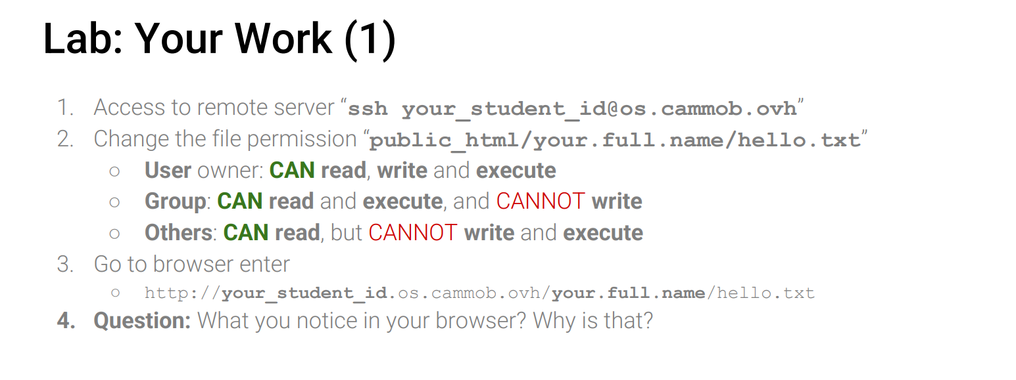
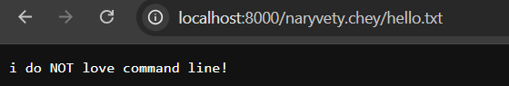
The browser displays the content of hello.txt because the file has all permission for owner, allowing the web server to read and show the file.

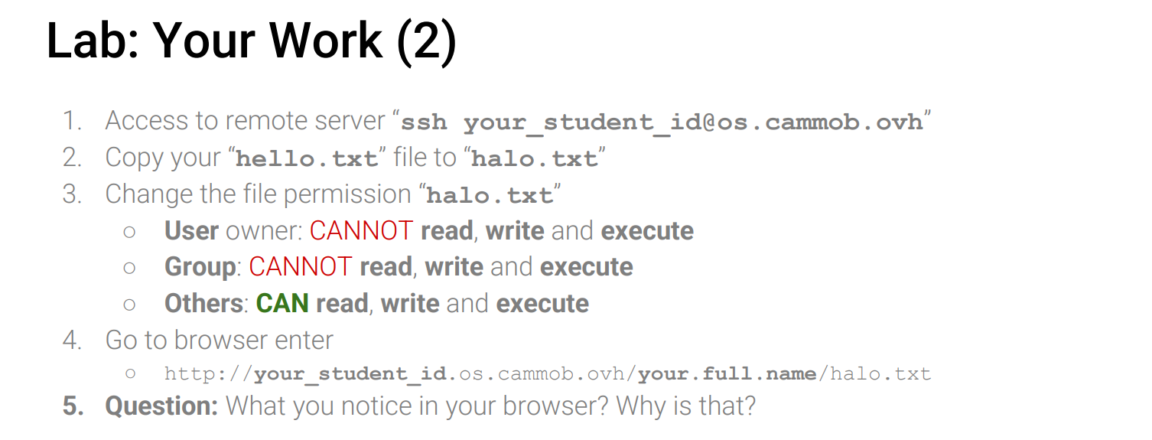
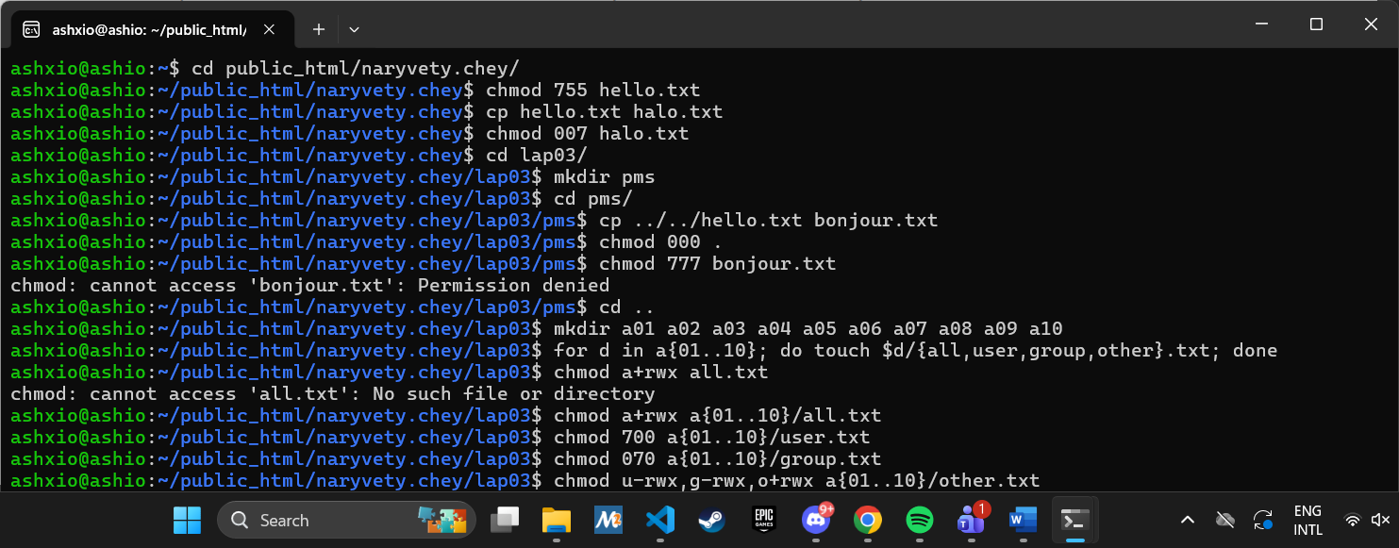
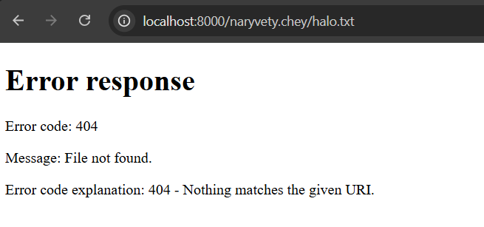
The browser shows an error because although others have permission on the file, it is also writable by others yet no owner/group permission halo.txt and are considered unsafe.

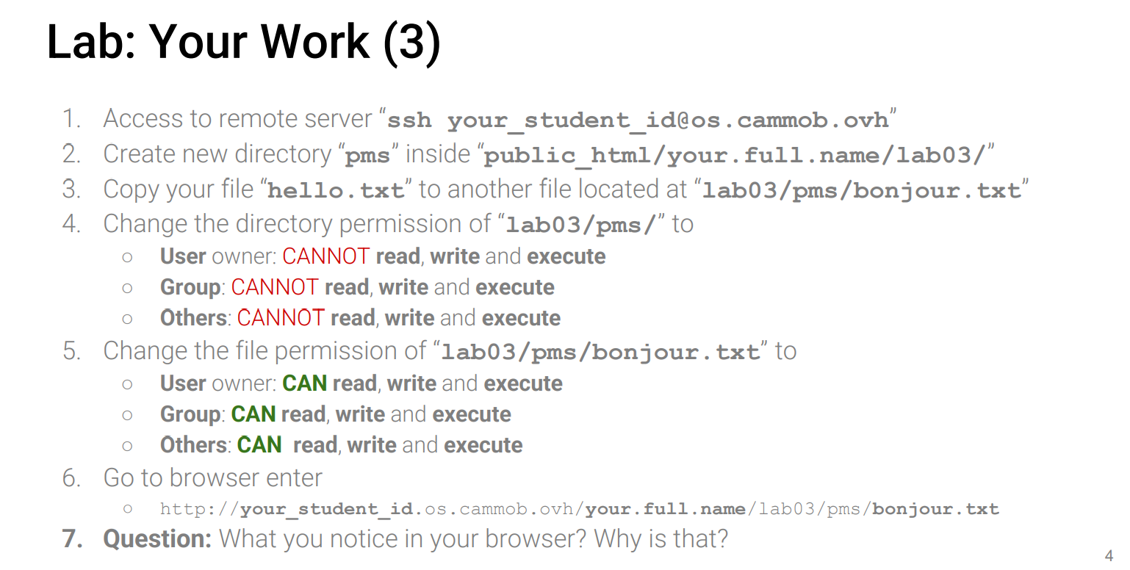
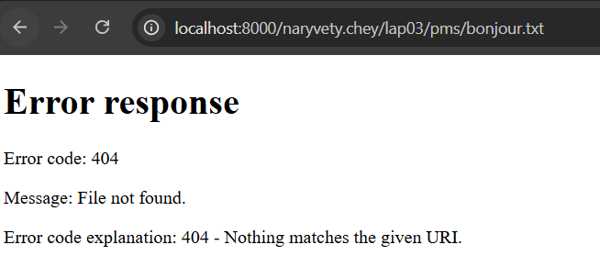
Browser shows error because changing the permission for bonjour.txt was impossible due to directory not have permissions at all and even if bonjour.txt allows all to read, write, and execute, the problem is that directory pms has NO permission.
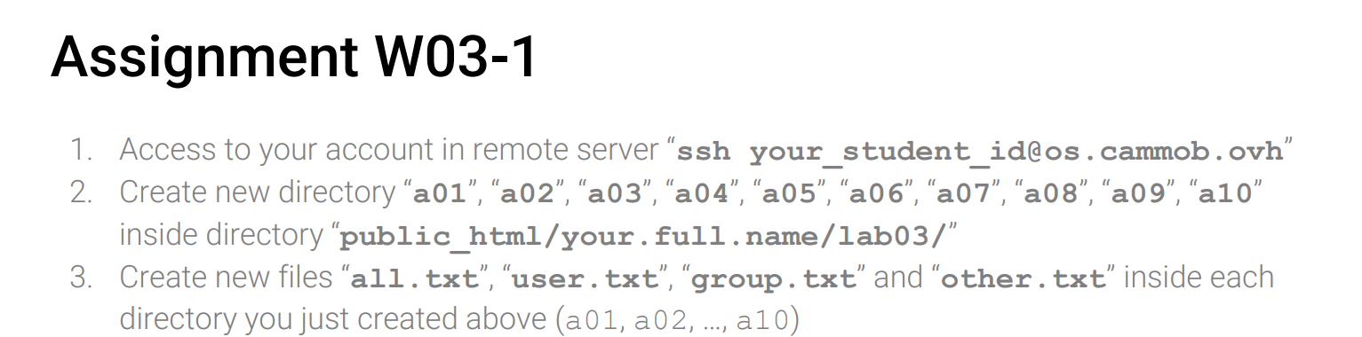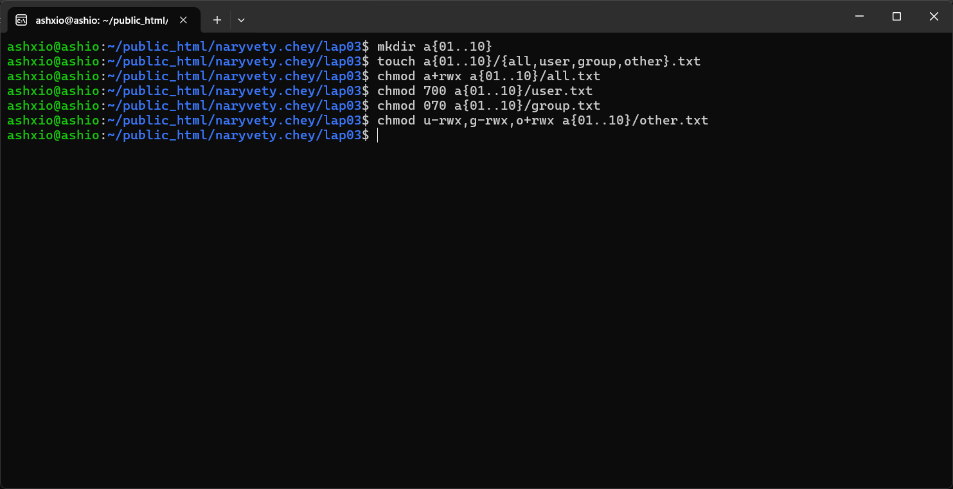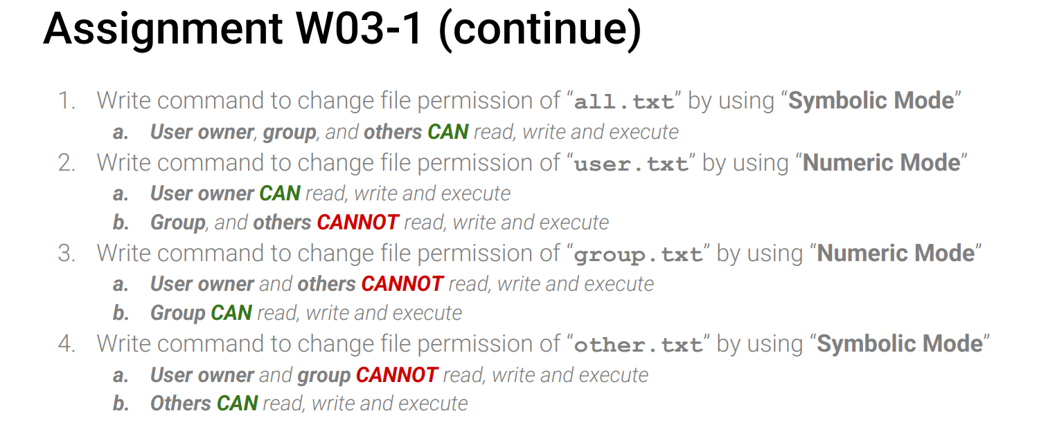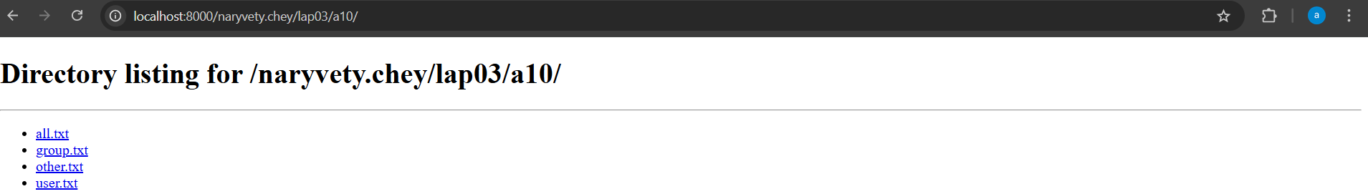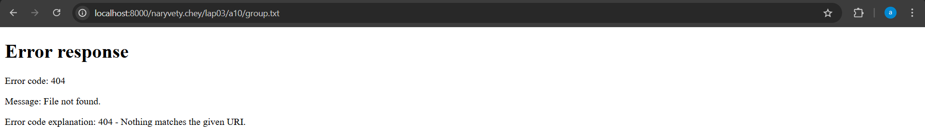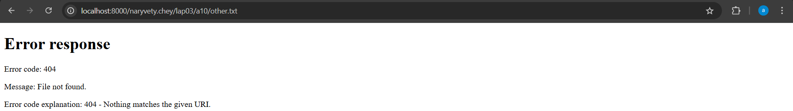

all.txt shown: all have read permissions
user.txt shown: user have all permissions
group.txt error: both owner and others don’t have permissions
other.txt error: no owner/group permissions only others permissions so they are considered unsafe.

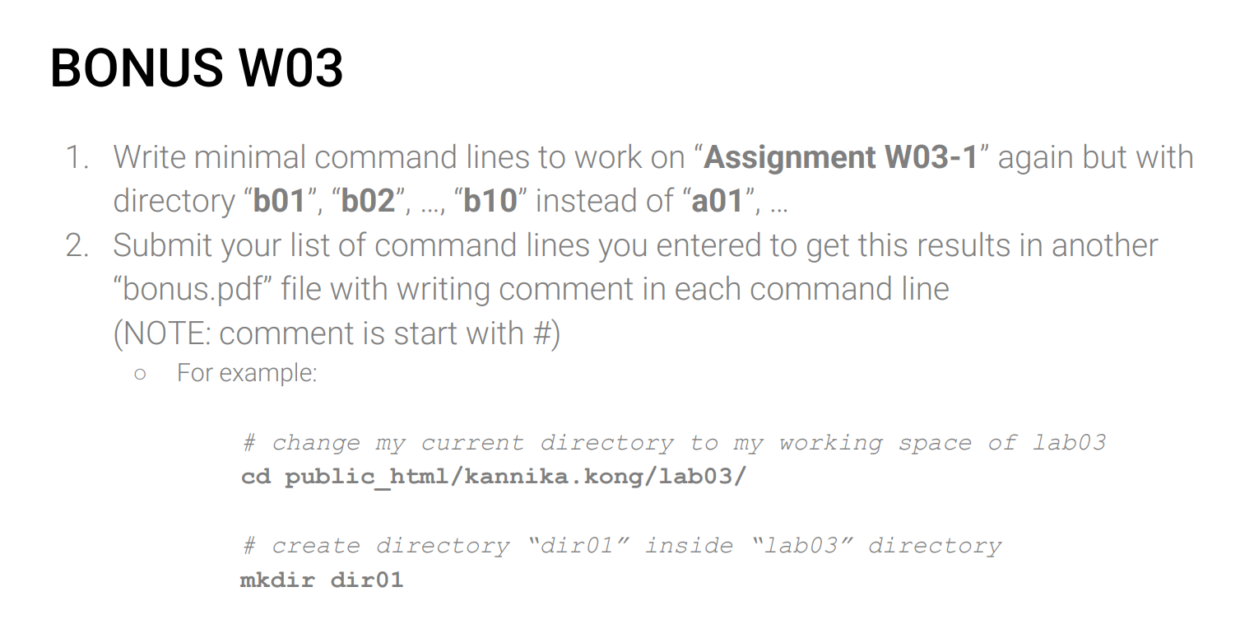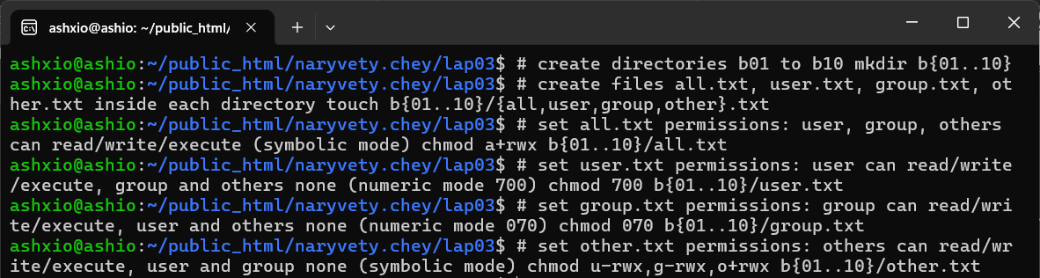
- To make a bunch of dir with the same starting name and numbers ascending from one num to another we can js use mkdir name with {fromnum..tonum} to represent the numbers in between those num
- To create a file in a dir we would write dir/filename.txt so to shortens it we can use {..}/{..} instead of writing a loop to add all four files into all dir. the first {} being all the dir the files go into and the second {} for files then just put .typefile u want create
- Numeric mode: first digit for user, second for group, third for others and r = 4, w = 2, x = 1
- Symbolic mode: u for user, g for group, o for other and a for all (user, group, other). Use (+) to give can permission and use (-) to give cant permission

